**Capstone Project Background Reading**

Arcade Games

Background

In the early 1980s the video game industry was growing steadily. There was a ‘golden age of arcade video games’ from 1978 to 1983. With popular releases such as Space Invaders(1978), Pac-Man(1980) and Donkey Kong (1981)[2], . following this economic boom the video games industry crashed in 1983 with many game developers going bust. [1] Many saw it as a failure of the industry, but following the bust the industry began to recover globally with classic hits such as Tetris(1984), Super Mario Bros(1985) and Blasteroids(1987). Later in the 90s there was a boom of the fighting genre of arcade games.[3] The release of the Mortal Kombat and Street Fighter games shaped the overall arcade game market for years to come. Those big Arcade games of the 80s and 90s have inspired countless modern re-iterations or similar games.

Real purpose to Arcade Games

The video game industry is the fastest growing software industry segment. [7. p25] Arcade games are not just used for fun. The development of games has often been used by new software engineers as a way to teach themselves computer science principles they can use in all spheres of software development.

But it is not just the process of creation of a video game that can have an educational benefit. Playing a video game can be very educational and useful, most arcade games can be in some way adapted for an educational purpose. Even a simple game like Tetris can solve an educational purpose, at MIT researchers created a web based vocabulary-drill version of Tetris. It works through the use of voice recognition in the form of Web Accessible Multimodal Interface software [8. p4]. The game begins like classic Tetris with a piece appearing at the top of the game board. The twist is that also an image appears every time, if its the first time, the image appears with the corresponding word. If the image is appearing for a subsequent time it appears without the word and this is when the player has to say the word associated with the image out loud to unlock block rotation. [8. p3] Through this the player learns new words and their meaning.

There are of course limitations to the ability of games to teach, and certainly adding learning to a game can often lead to lesser enjoyment overall enjoyment of the game. [8. p5] This necessitates the developer to often choose between either high learning effectiveness or fun when choosing how to implement features.

Those educational games and other games which have a certain positive goal besides entertainment are sometimes called serious games. To be considered a serious game it has to have a positive goal such as promoting health or educate a person on a certain topic. [14. p21] Though it is often difficult to create a serious game with an actual learning benefit, due to the difficulty of actually assessing weather the game possesses actual learning value. Which is why there is a lot of research going into learning analytic.

Smart-phones are considered a promising platform for serious game development due to their widespread availability, ease of use, flexibility and personalisation which makes acquiring data about their learning potential easier. Furthermore a system for mobile and PC while likely somewhat different they can complement each other and work best together. [14. p23]

Competition

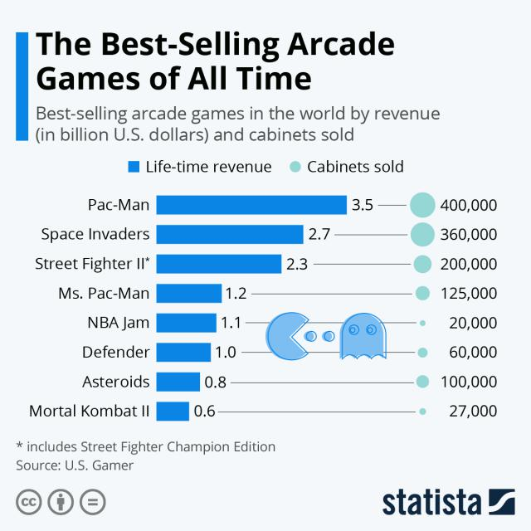

Image 1[5]

Tetris

* First version released: 1984
* Simple gameplay - hard to master
* Influenced hundreds of ‘copy-cat’ versions and releases.
* Fast paced ‘puzzle’-like gameplay
* EA mobile phone version sold over 100 million [4]

Pac-Man

* Released: 1980
* One of the highest-grossing and best selling arcade video game series of all time
* Pioneered non-violent arcade gameplay. [5]

Super Mario Bros

* Released: 1985
* Grew into a globally famous franchise with dozens of sequel and spin-off releases.
* One of if not the most influential side-scrolling video game.
* Latest iteration of Super Mario Bros, ‘New Super Mario Bros U’ for the Wii U released in 2012 sold 5.8 million copies. [6] Showing that the ‘Super Mario Bros’ franchise is still alive and well after almost 40 years.

Possible technologies to use

From my research I had been led to the conclusion that Arcade games are most popular on mobile devices. The small touch screen controls of Android and iOS favours the simpler arcade kind of games [9] whilst windows computer games with keyboard, mouse and possible periphery control gadgets led gamers owning those devices to be more inclined towards more complicated and competitive games.

LibGdx - A flexible cross-platform 2D video game development framework based on OpenGL 2.0 and the Java programming language with some C and C++ components for performance intensive code It allows a project to target Windows, Linux, Mac, Android and iOS. Supports many 3rd party tools. Has low level OpenGL helper features such as meshes, textures, framebuffer objects etc. Additionally contains high-level 2D APIs relevant to my project such as Othographic camera, sprite batching and caching, 2D particle system and a TMX tile map support.[10]

SFML - Simple and Fast Multimedia Library, it is a simple interface for the development of games and multimedia for multiple operating systems, Windows, Linux and macOS. It is a C++ API but can be utilised from C#, Java and Python among many others. It is an exclusively 2D graphics based library. It is more of a cross platform layer abstraction API rather than a straight game development framework. [12]

Pygame - Is a Python game programming library used for the development of 2D games. It is based on SDL. It allows for easy multi threading, utilises optimized C and assembly code for core functions, which is much faster than Python code. It prides itself on being easy to use due to requiring a small amount of code while giving the user a lot of control over their game. Many indie games have been made with it. It is very modular so its possible to utilise different libraries for specific aspects of the game. [13]

Java- Java has Swing and Awt which can be used for 2D graphic work, this makes the language able to be utilised for making arcade games without any external libraries. It is great for Windows development and doesn’t require any installation porting the game to Android is trivial. Porting to other platforms is also possible due to the JVM but harder.

rise.global - Allows for the creation of dynamic real-time leaderboards from a CSV file (Comma Separated Values) or excel spreadsheets. Useful for adding a player versus player (in terms of score) competitive element or a goal to an arcade game. It has an extensive list of features such as email updates, score card, scheduling of score collection, etc. [11]

References

1. New York Times (1983, Oct. 17) by N. R. Kleinfield, Available: <https://www.nytimes.com/1983/10/17/business/video-games-industry-comes-down-to-earth.html>

[2] USgamer (2016, Jan. 1) by Jaz Rignall, Available: <https://www.usgamer.net/articles/top-10-biggest-grossing-arcade-games-of-all-time>

1. GAMERANT (2020, Sep. 11) by John Rinyu, Available:

<https://gamerant.com/best-90s-arcade-games/>

1. EA (2010, Jan. 21) by Itucker, Available: <https://www.ea.com/news/tetris-game-surpasses-100-million-mobile-downloads?isLocalized=true>
2. Statista (2020, May. 19) by Katharina Buchholz, Available: <https://www.statista.com/chart/21768/best-selling-arcade-games/>
3. Nintendo Available: <https://www.nintendo.co.jp/ir/en/finance/software/ds.html>
4. K.B, Becker, “Teaching with games: the minesweeper and asteroids experience”. *Journal of Computing Sciences in Colleges.* Vol. 17, issue 2, pg 23-33, Available: <https://citeseerx.ist.psu.edu/viewdoc/download?doi=10.1.1.473.5072&rep=rep1&type=pdf>
5. C.J.C, Cai “Adapting Arcade Games for Learning”. *Extended Abstracts on Human Factors in Computing Systems*. Pg 2665-2670, Available: <https://citeseerx.ist.psu.edu/viewdoc/download?doi=10.1.1.294.5335&rep=rep1&type=pdf>
6. H.B-L.D “Playing Different Games on Different Phones: An Empirical Study on Mobile Gaming“. *Proceedings of the 10th international conference on Human computer interaction with mobile devices and services.* Pg 391-394 Available: <https://dl.acm.org/doi/pdf/10.1145/1409240.1409296>
7. BadLogicGames Available: <https://libgdx.badlogicgames.com/features.html>
8. Rise.Global Available: <https://www.rise.global/>
9. SFML frequently asked questions Available: <https://www.sfml-dev.org/faq.php>
10. Pygame Available: <https://www.pygame.org/wiki/about>
11. L.S, Laila Shoukry, “Learning Analytics and Serious Games: Trends and Considerations” *Proceedings of the 2014 ACM International Workshop on Serious Games.* Pg 21-26 Available: <https://dl.acm.org/doi/pdf/10.1145/2656719.2656729>